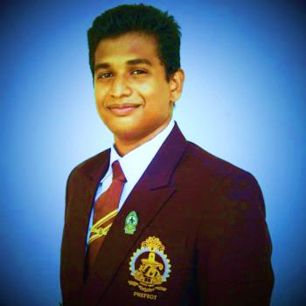CURRICULUM VITAE

SIVAKUMAR HARIKRISHANTHAN

**FULL NAME**

**SIVAKUMAR HARIKRISHANTHAN**

**PREFERRED NAME**

**S.HARIKRISHANTHAN**

**E-MAIL**

[**SOLAN.S@HOTMAIL.COM**](mailto:SOLAN.S@HOTMAIL.COM)

**CONTACT NUMBER**

**0758516012**

**0754777663**

**0777798143**

**ADDRESS**

**32,BOSWELL PLACE,**

**WELLAWATTA,**

**COLOMBO-06.**

**DATE OF BIRTH**

**29TH MARCH 1996**

**NATIONALITY**

**SRI LANKAN**

**GENDER**

**MALE**

**MARITAL STATUS**

**SINGLE**

**HEIGHT: 5.6’**

**WEIGHT: 70kg**

**PASSPORT NUMBER**

**N5591409**

**SCHOOL ATTENDED**

**C/VIVEKANANDA COLLEGE**

**C/HINDU COLLEGE**

**EDUCATIONAL QUALIFICATION**

**Passed G.C.E. Ordinary Level(Tamil medium)2012**

Subject Grade

**Mathematics A**

**Commerce A**

**Religion A**

**History B**

**Information Technology C**

**Drama & Theater C**

**Tamil C**

**English C**

**Science S**

**EXTRA CURRICULAR ACTIVITES**

* **Senior Prefect(2014/2015)**
* **Director of Interact club(Community service)**
* **Editor of school magazine**
* **Member of Mother Sri Lanka**
* **Member of Media unit**
* **Member of Tamil union**
* **Member of English union**

**GAMES&ATHLETICS**

* **Vice secretary of school athletic meet**
* **Under17 Volley ball team member**
* **Chess team member**

**WORK EXPERIENCE**

**WORKING AS A TRAINEE**

**High Commission of India**

**IVS lanka (Pvt)**

**NON-RELATED REFEREES**

**Mrs.K.Sababathipilli**

**SLPS-2 II , MA (Pub.Adm)**

**Deputy Principal,**

**C/Hindu college.**

**Mobile:0777872904**

**Mr.M.A.Jeewaka Kumara**

**Accounts Executive,**

**Indian Visa Center,**

**IVS lanka(pvt),**

**129,Philip Gunawardana M.W,**

**Colombo-04.**

**Mobile:077402063**

**The above information provided by me is true and accurate to the best of my knowledge.**

**Signature: Date:**